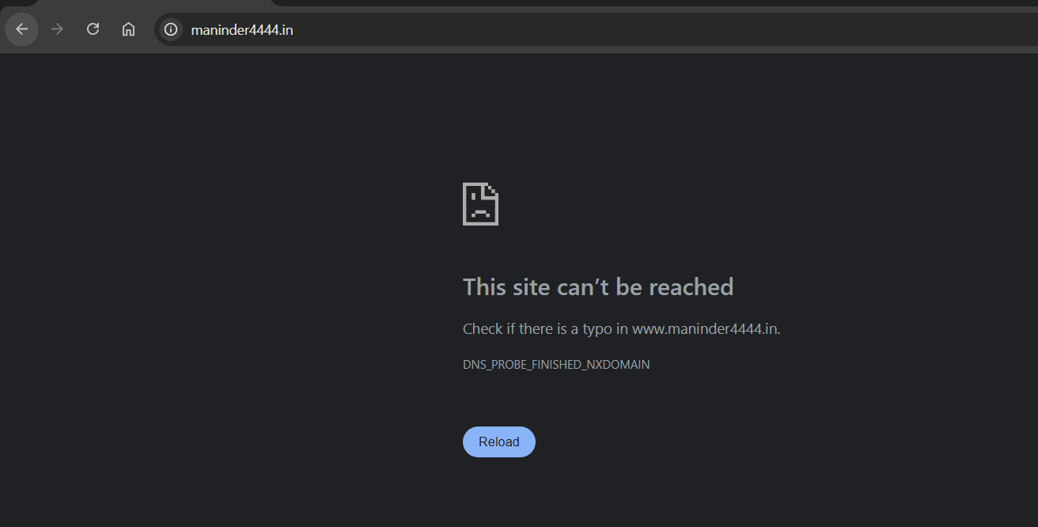

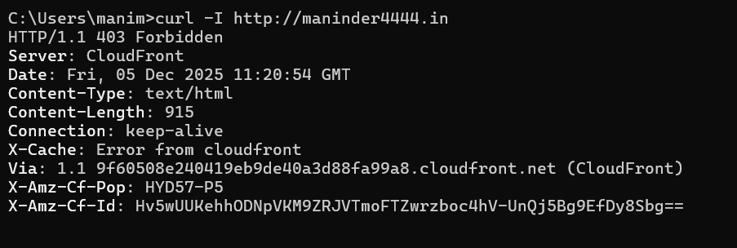

Checking CloudFront distribution status in console, if any recent invalidations are pending?
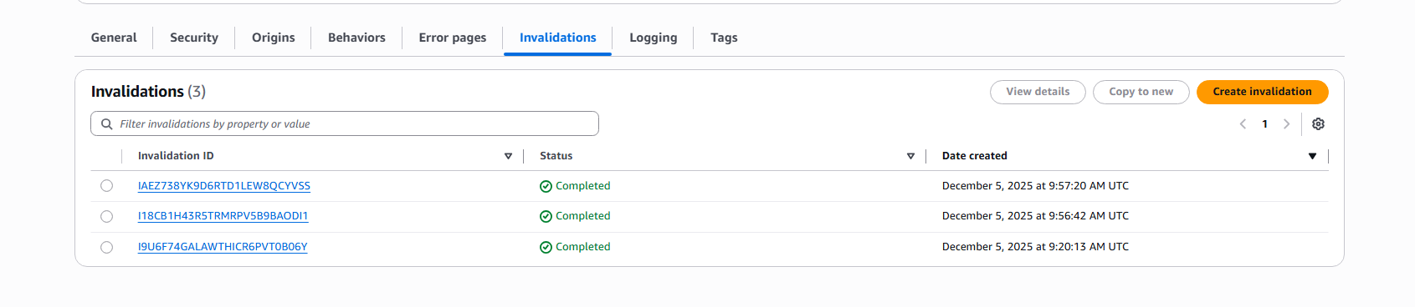
No pending invalidations are found,

Checking if cloud distribution name URL is working or not, it is working as follows
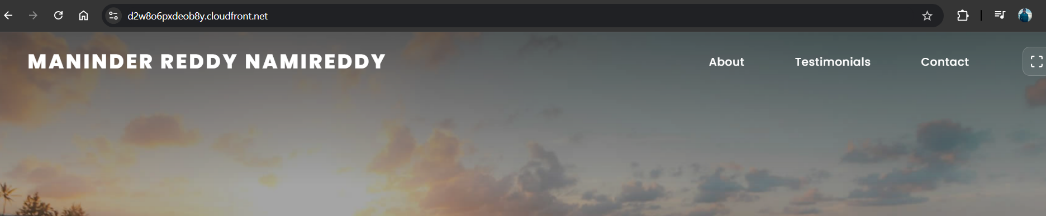
So, the problem is likely DNS/ACM
I have tried changing the CNAME Name, with the prefix content deleted, since the extension contained the prefix in the CNAME, But shown Error, when tried
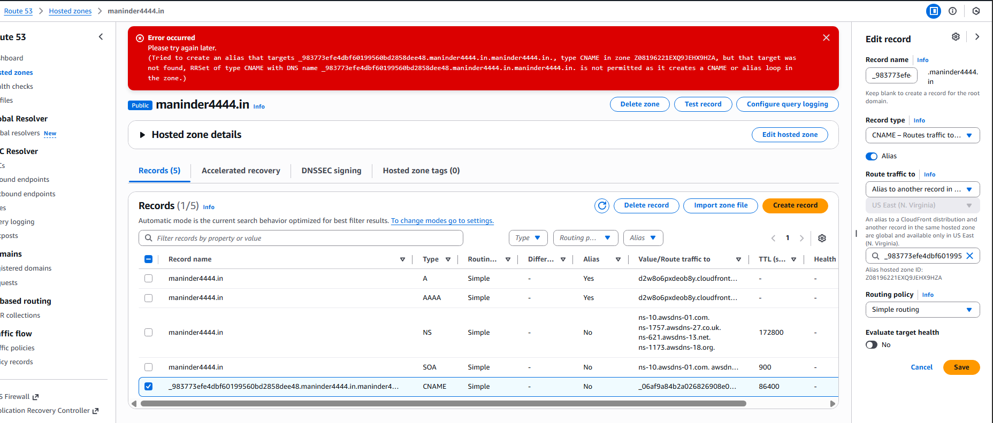

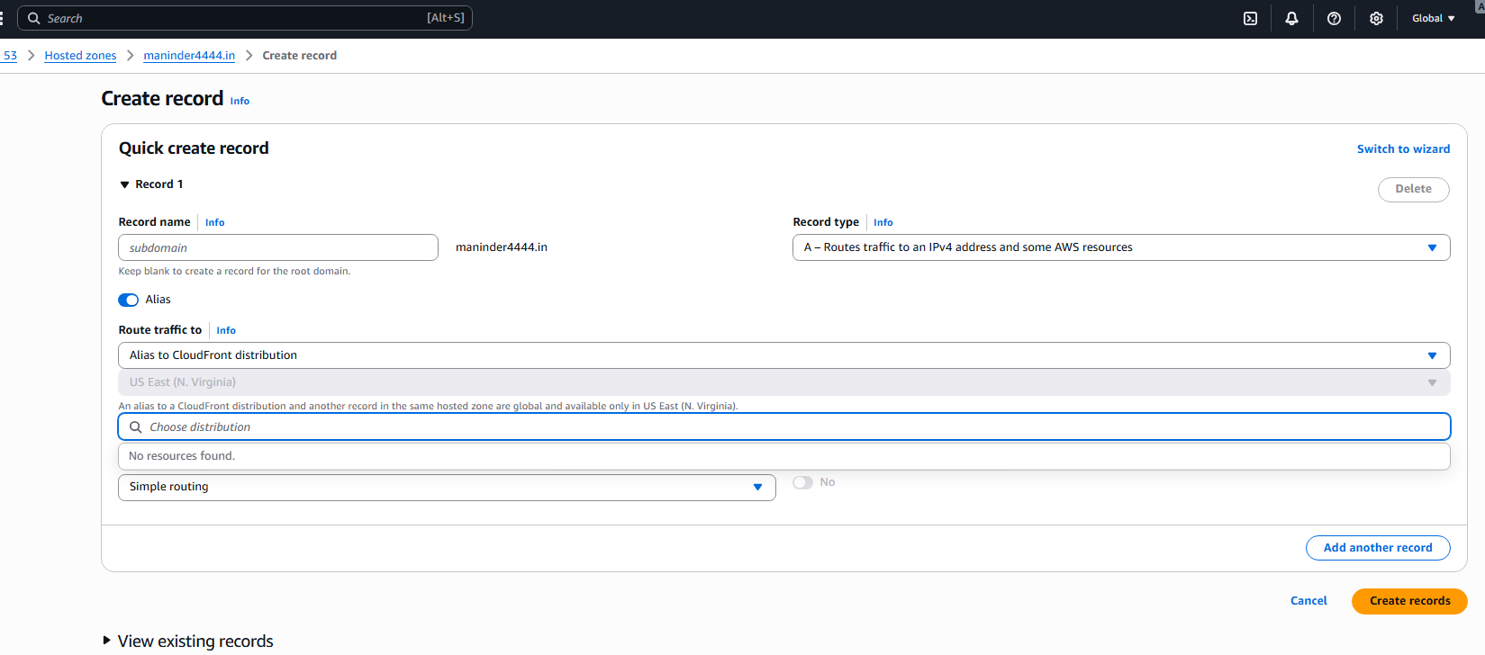
When trying to give the A route type when opted the Alias, Alias to CloudFront distribution the destination is not shown but I have given the distribution id explicitly before.

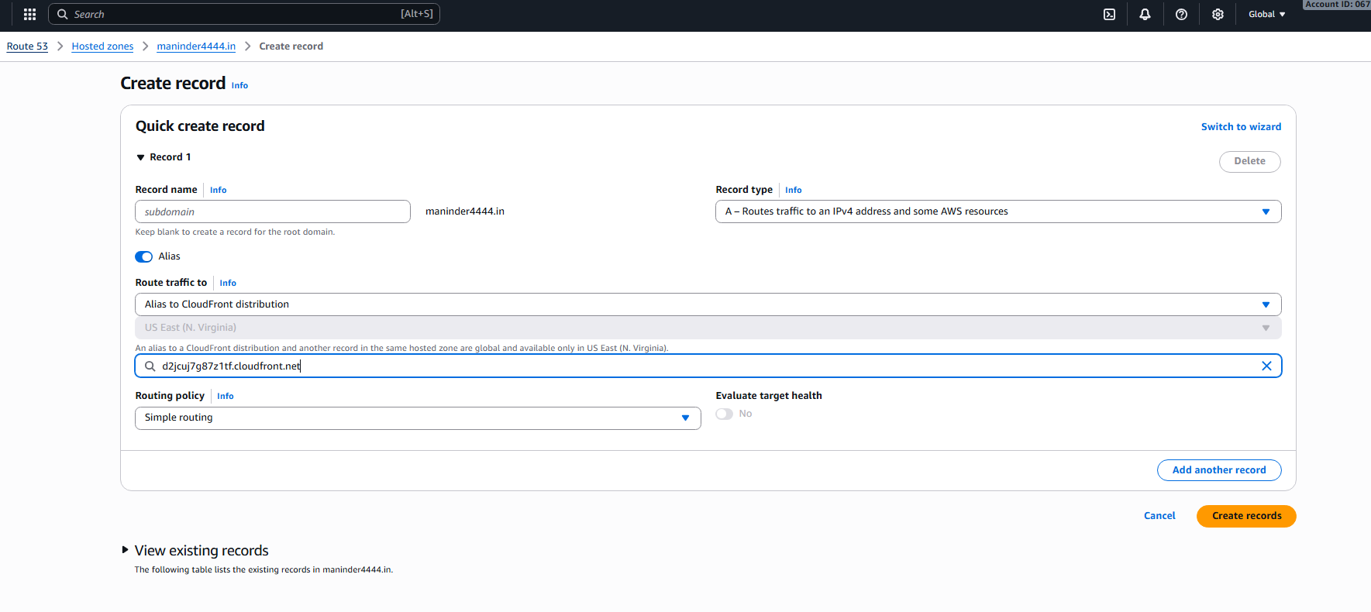
Now I have tried provisioning the s3 bucket from the us-east-1 and also obtained the ssl certificate from the us-east-1
Now when I have done the process from the beginning, I got the result as intended.

